Gladys Seisa
2805000512
19/07/2026

Introduction
I have built a working Data Agent on Databricks that answers business questions about a TV station dataset. This includes the agent's instructions on what it can do and what I cannot do.

The Objective
Building a TV station Data Agent on Databricks using the provided User and Viewership dataset. The agent must help a business user, manager, or CEO ask questions about the TV station performance and receive useful business insights in plain language, backed by real data.

Data description
In this data we have the Usera and Viewership tables the are joined using the Join statement. The tables contain UserID which is a unique identity of each viewer, Channel, Duration which is in HH:mm:ss, Age, Province, Race, RecordDate which includes the viewing date and time.

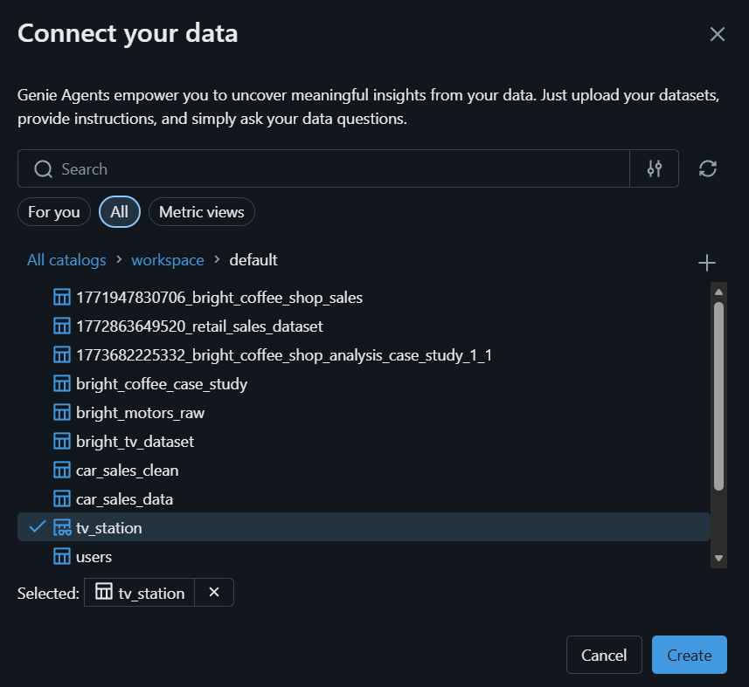
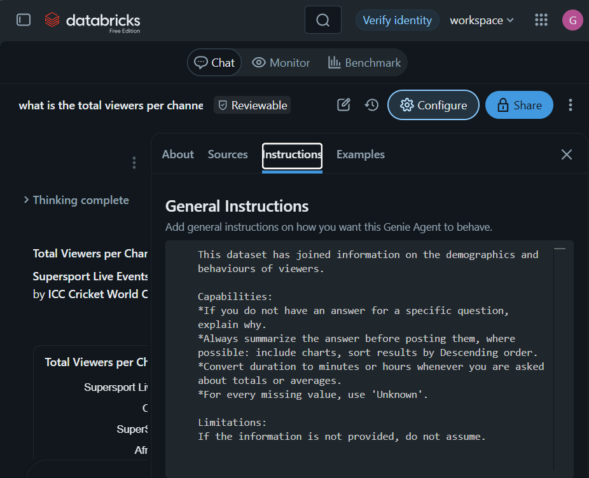
Instructions:
This dataset has joined information on the demographics and behaviours of viewers.

Capabilities:
*If you do not have an answer for a specific question, explain why.
*Always summarize the answer before posting them, where possible: include charts, sort results by Descending order.
*Convert duration to minutes or hours whenever you are asked about totals or averages.
*For every missing value, use 'Unknown'.

Limitations:
If the information is not provided, do not assume.

QUESTIONS
- What is the total of viewers per channel?
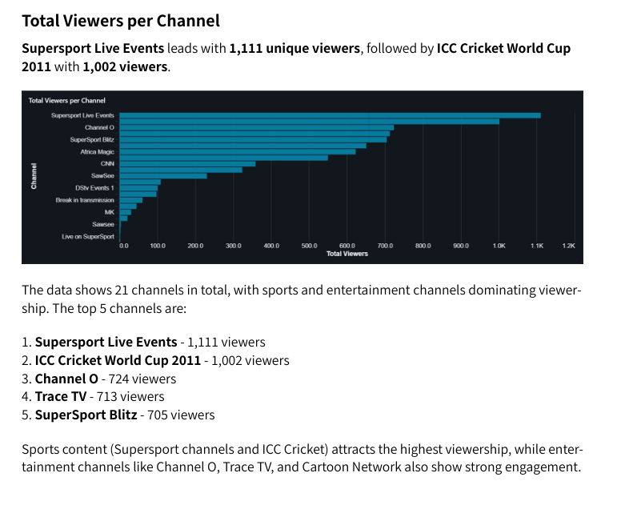
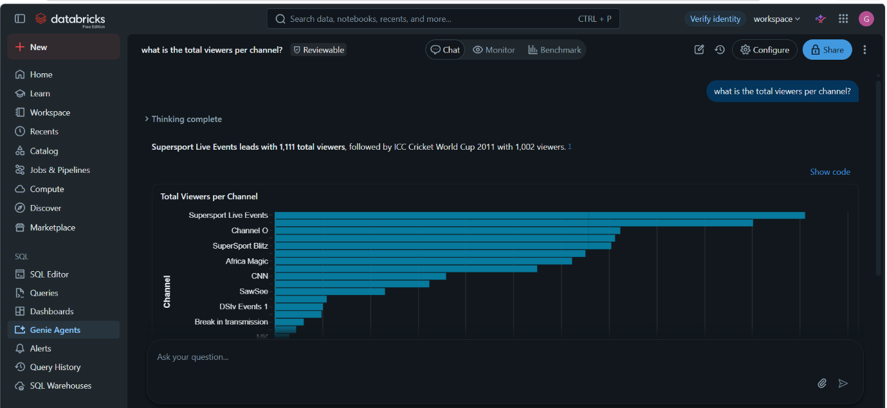

2.In which province do we have the highest viewers?
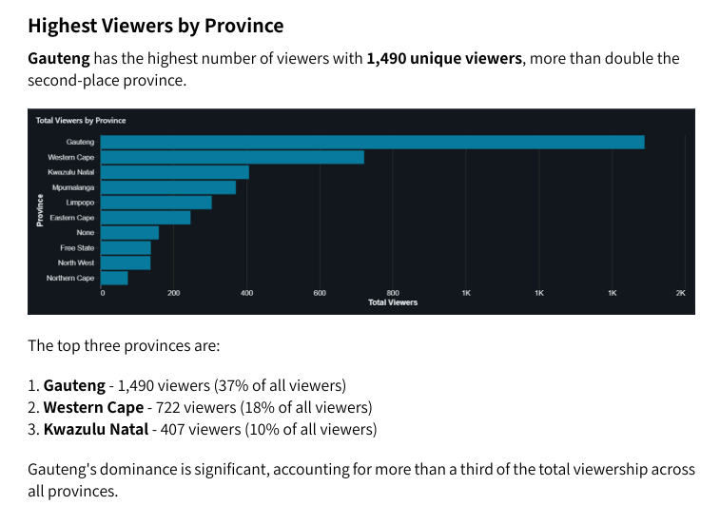
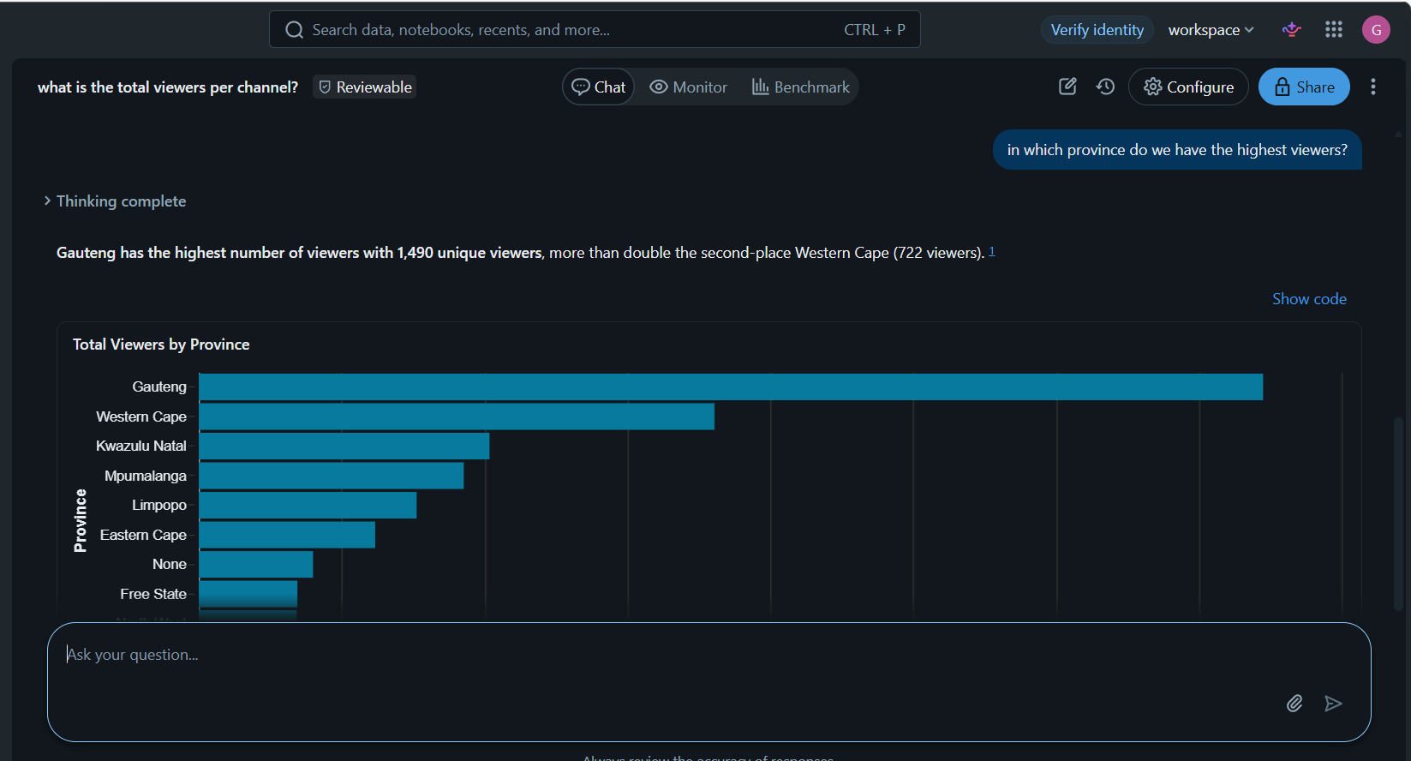

- What are the top 3 channels by watch time?
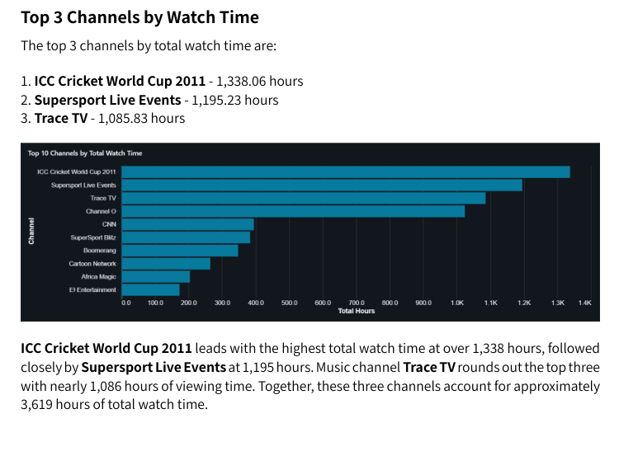
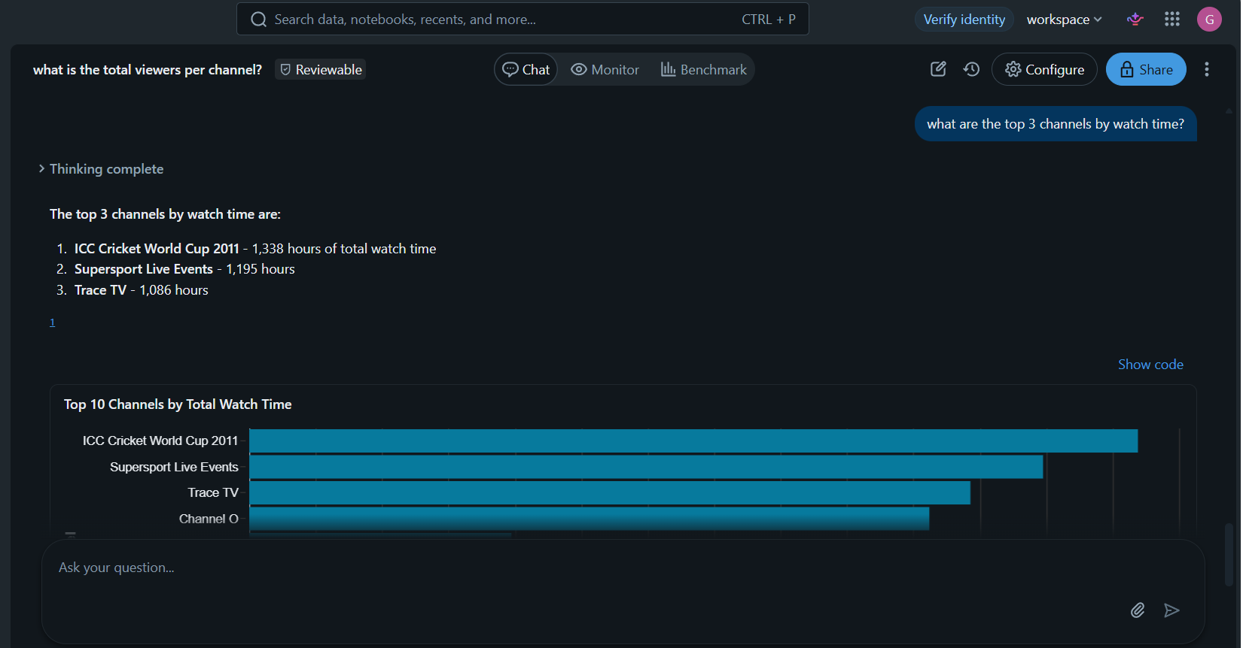

- Which Race and Gender has the highest viewers per channel?
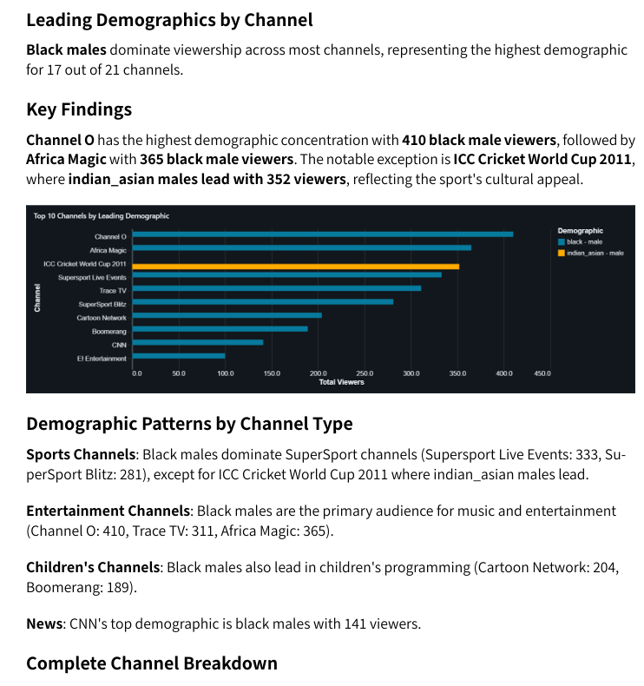
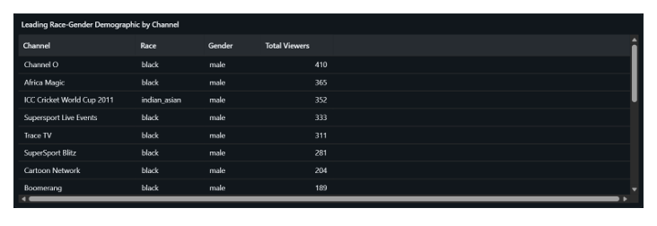
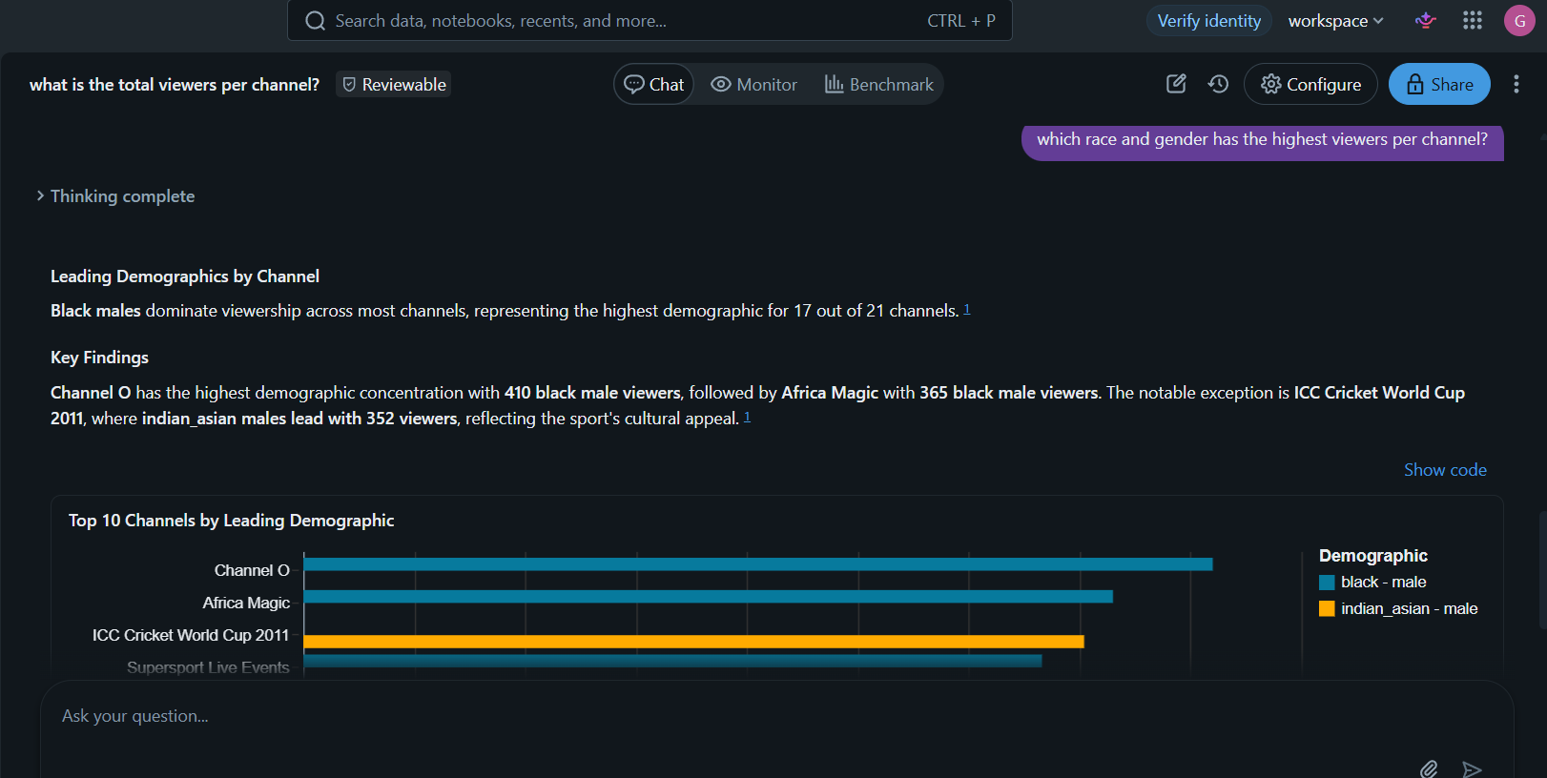

- What is the average viewing time?
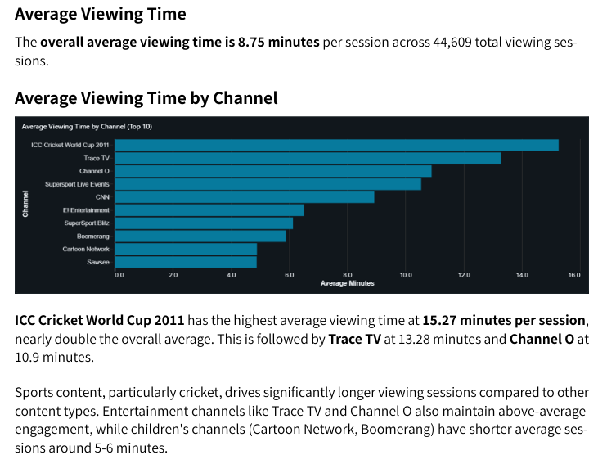

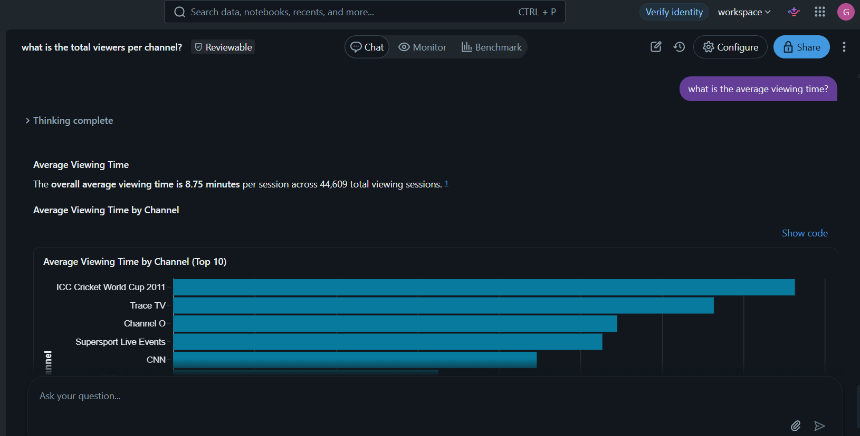

- What age group watches the most TV?
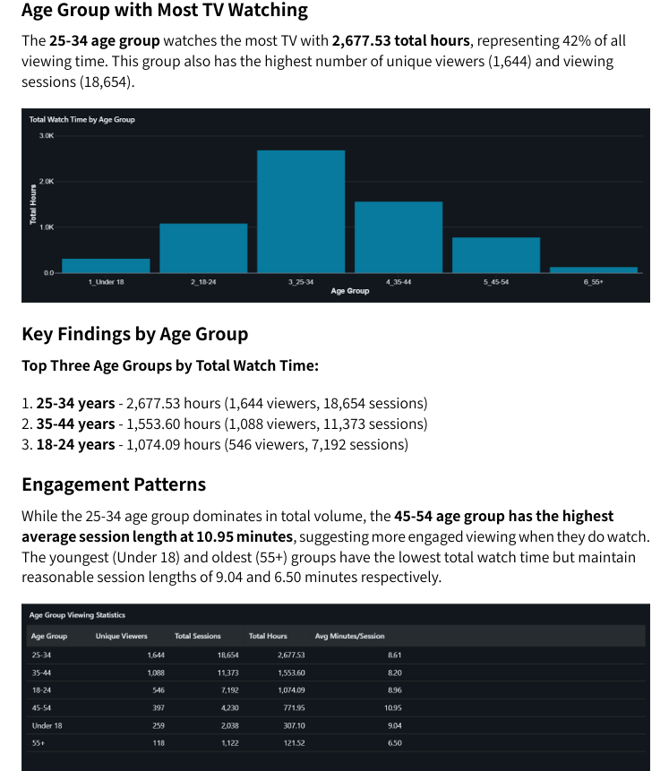
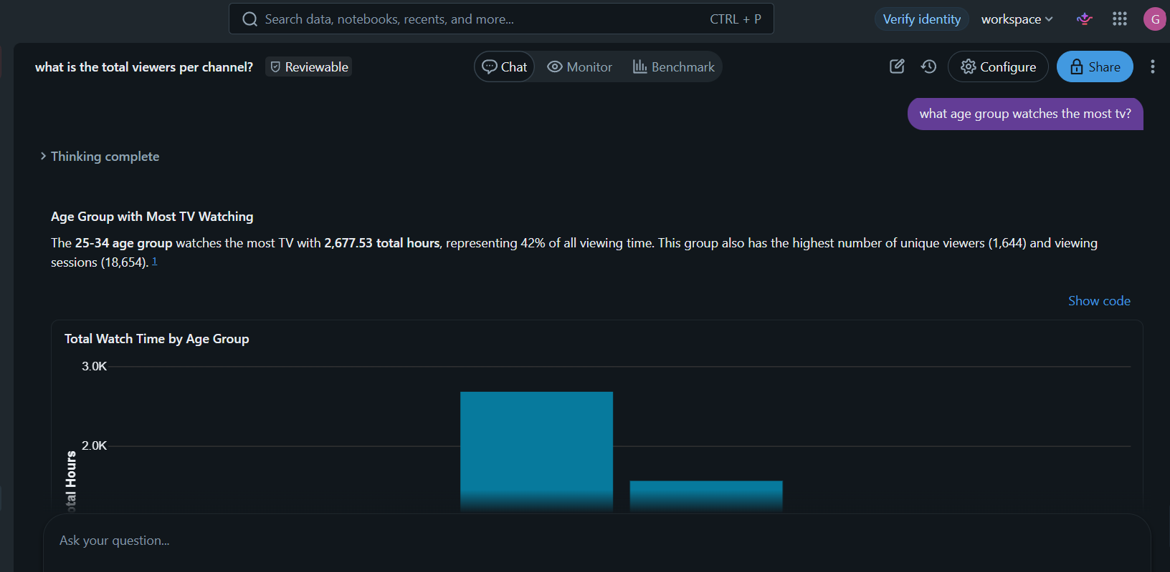

- What gender has the most viewers?
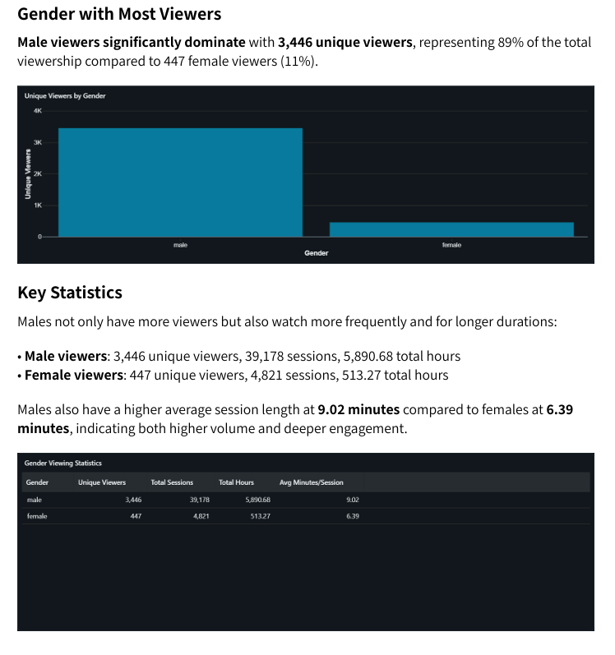
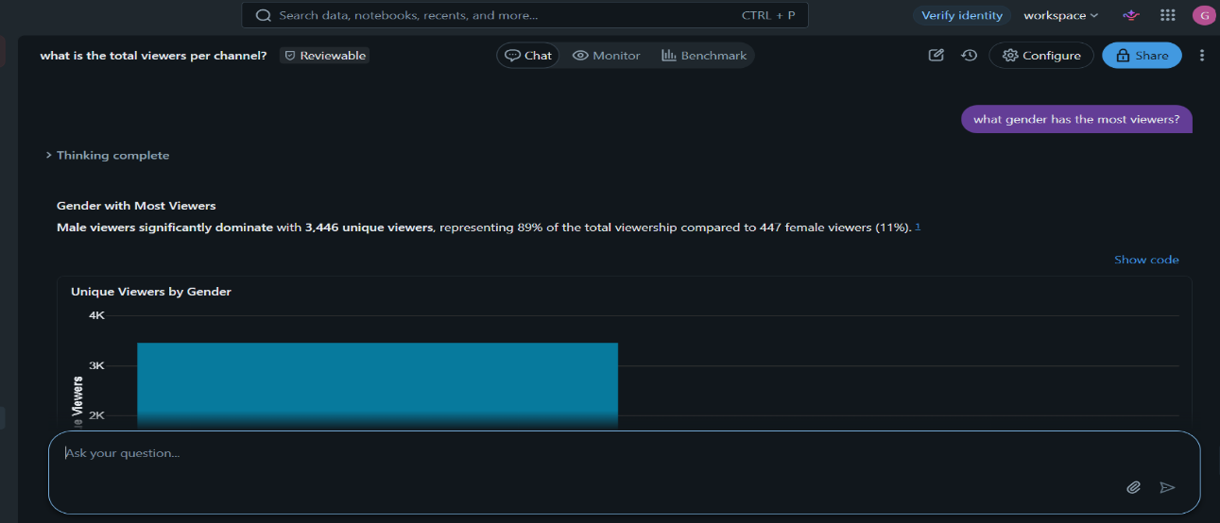
- Between weekdays and weekends, which has the most viewers?
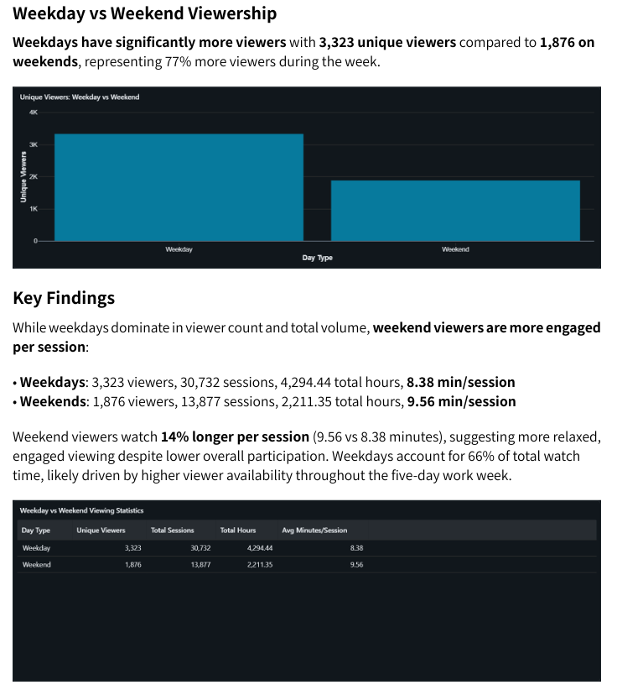
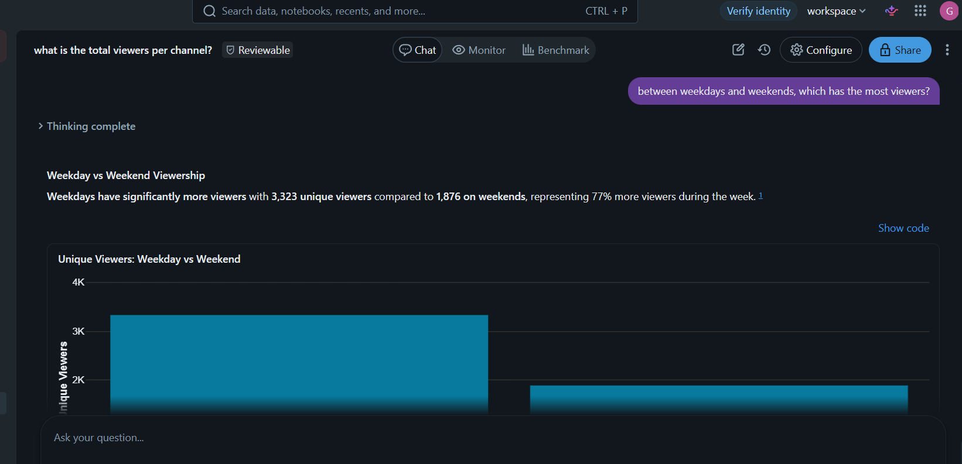
- What is the number of returning viewers?
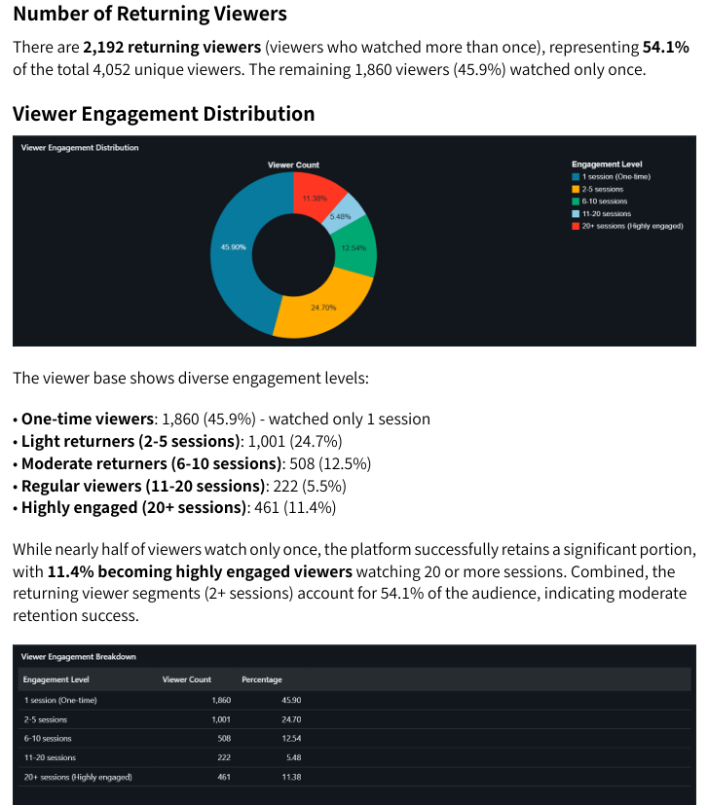
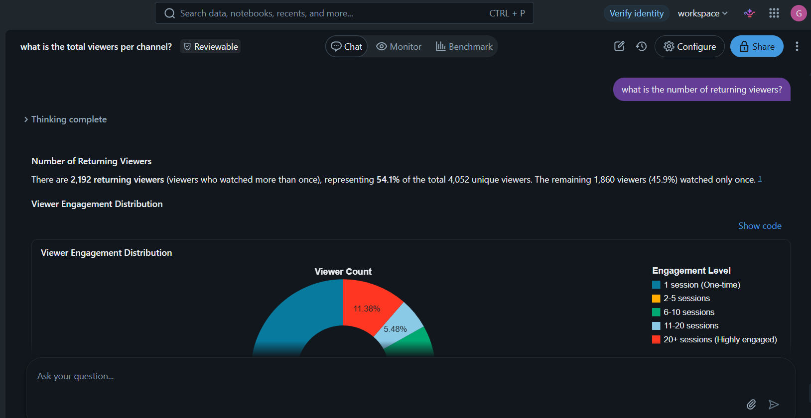
- Which channel has the highest female viewers?
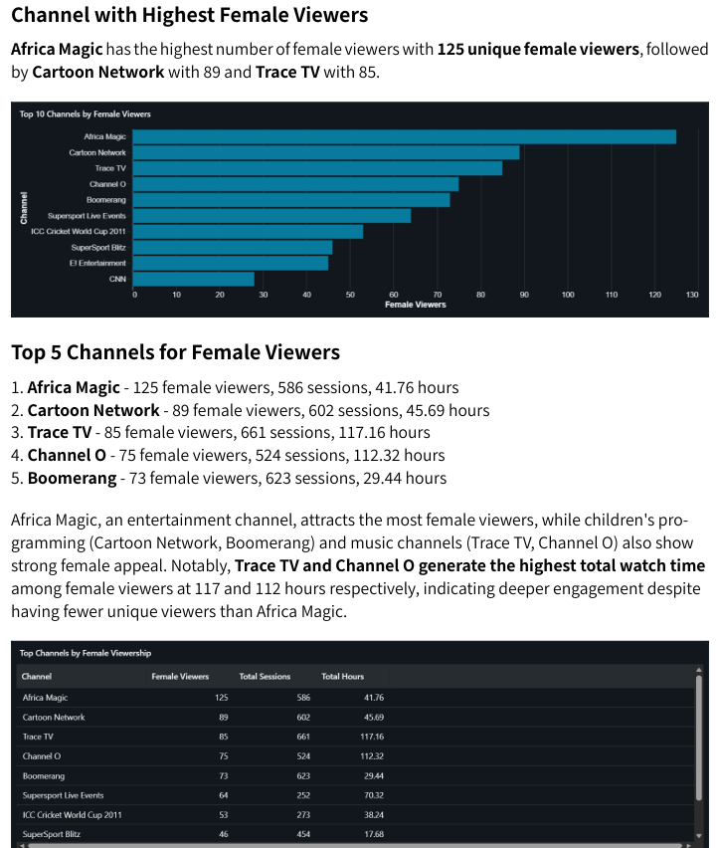
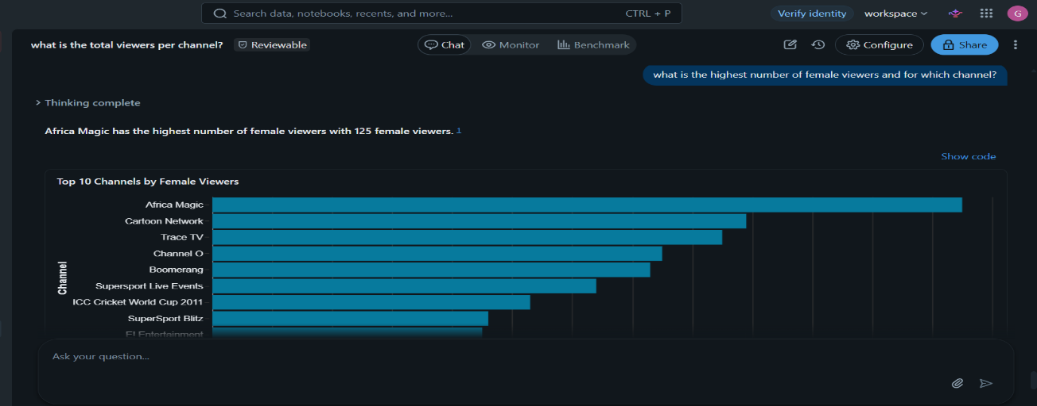
Validation

select * from `workspace`.`default`.`users_1` limit 10;

select * from `workspace`.`default`.`viewer` limit 100;

select *
from `workspace`.`default`.`users_1` u
join `workspace`.`default`.`viewer` v
on u.UserID = v.userid4;

create view TV_Station as
select u.UserID, v.Channel2, v.RecordDate2, v.`Duration 2`, u.Gender, u.Race, u.Age, u.Province
from `workspace`.`default`.`users_1` u
join `workspace`.`default`.`viewer` v
on u.UserID = v.userid4;

--checking for total viewers
SELECT
COUNT(UserID0) AS Total_viewers
FROM `workspace`.`default`.`viewers`;

--Checking for users based on race
SELECT race, count(*) as race
FROM `workspace`.`default`.`users`
GROUP BY race
ORDER BY race DESC;

--Checking for Users based on their age, gender and race
SELECT UserID, age, gender, race
FROM `workspace`.`default`.`users`;

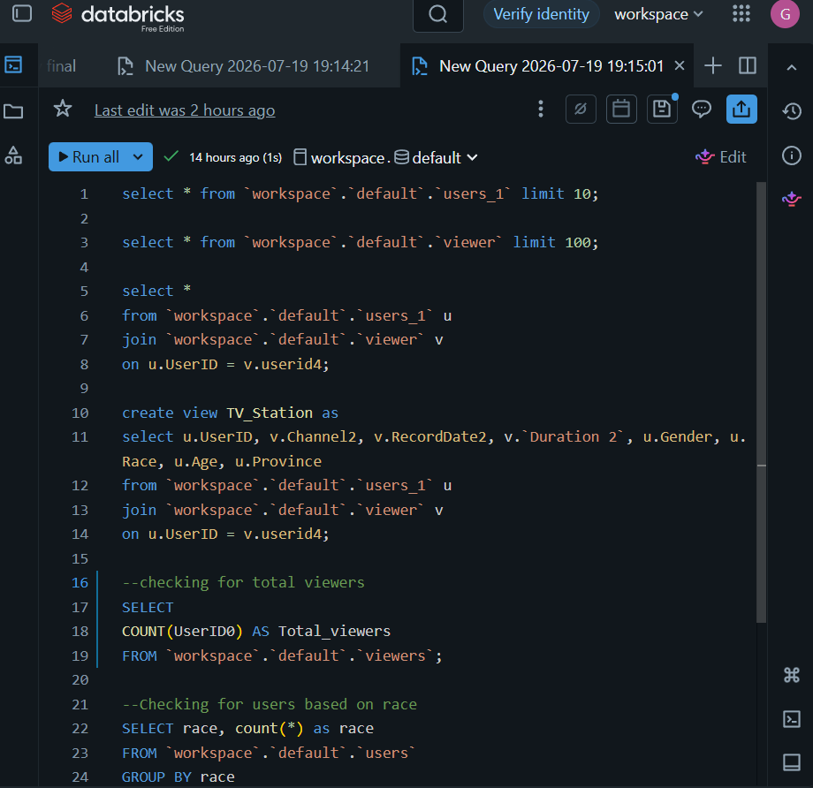

KEY INSIGHTS
*SuperSport Live Events channel has the highest viewers at 1.1k followed by the ICC Cricket World cup at 1.0k, suggesting that sport channels are highly favoured by the males at 89% viewership.

*The average viewing time is at 8.75 minutes and the highest being 15.27 minutes, which tells us that viewers prefer short duration programs.

*The 25-34 age group is leading in total watch time, at 42% of the overall viewing time.

RECOMMENDATIONS
*The TV station should spread the sport programs across both weekdays and weekends to increase viewership and their view time.

*More focus should be given to the female audience, making visible the channels they prefer.

*Advertisements and marketing of the high performing channels around peak hour times to attract more viewers.

CONCLUSION
The asking of questions becomes easier as you go, and you get to realise what instructions you can give to the agent.
Finding your way around Databricks is a bit of a challenge.
I wouldn’t change anything, with more practice, the exercise will become easier to do.

